**Ideation Phase**

**Empathize & Discover**

|  |  |
| --- | --- |
| Date | 27 June 2025 |
| Team ID | LTVIP2025TMID35544 |
| Project Name | smartsdlc – AI-enhanced software development lifecycle |
| Maximum Marks | 4 Marks |

**Empathy Map Canvas: Here’s a compact Empathy Map summary for SMARTSDLC – AI-Enhanced Software Development Lifecycle:**

* **Thinks: “How can we deliver smarter, faster, and with fewer errors?”**
* **Sees: AI-driven tools improving planning, testing, and monitoring.**
* **Says: “AI just flagged a bug we didn’t notice—awesome!”**
* **Hears: Feedback loops and suggestions from intelligent systems.**
* **Feels: More empowered, less overwhelmed.**
* **Pains: Initial AI learning curve, trust in automation.**
* **Gains: Higher efficiency, smarter insights, continuous improvement.**

**Example:**

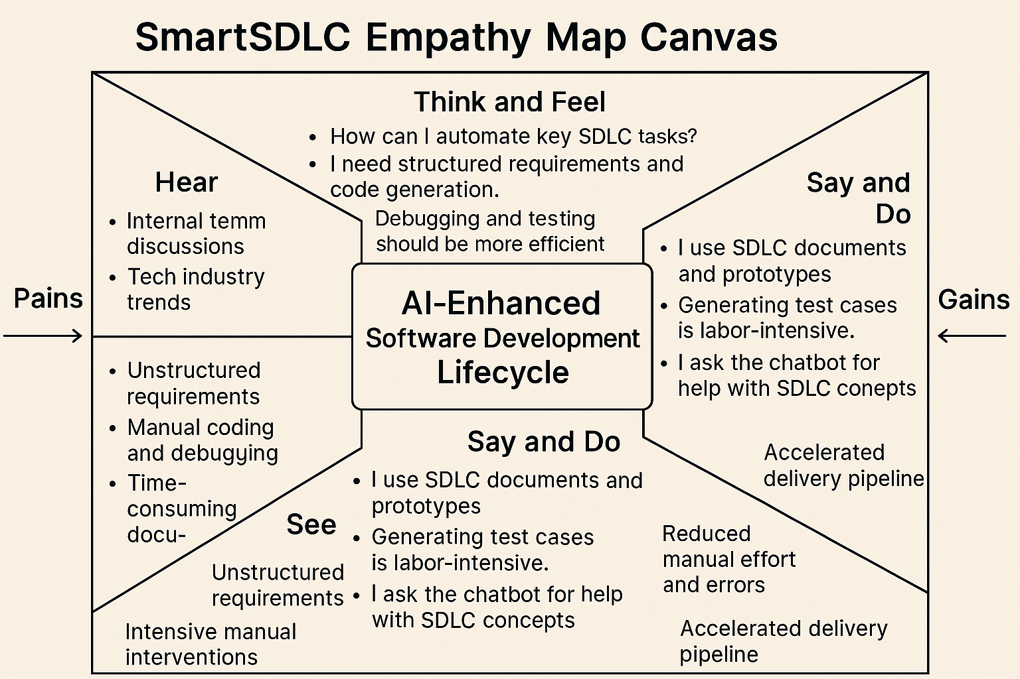

Reference: <https://www.mural.co/templates/empathy-map-canvas>

**Example: SMARTSDLC – AI-Enhanced Software Development Lifecycle in banking sector.**

**The image presents a visual summary of the SMARTSDLC – AI-Enhanced Software Development Lifecycle, structured as a circular workflow. It outlines the integration of artificial intelligence at each phase of software creation, including:**

* **Planning – Leveraging AI to define goals and anticipate development needs.**
* **AI Design – Architecting intelligent systems that adapt and learn.**
* **Analysis – Using data-driven insights to refine requirements.**
* **Testing – Automating and improving quality assurance with AI-powered tools.**
* **AI Monitoring – Continuously observing system performance for proactive updates.**
* **Review – Reflecting and learning from outcomes to guide future development.**

